December 29, 2014

INS3121
SOIL MECHANICS
FINAL EXAM
S.1 | S.2 | S.3 | S.4 | S.5 | TOTAL

Name Surname:
Student No:
Group:

Q1. a) Classify the following inorganic soils by the Unified Soil Classification System(USCS).
 | Sieve Number | 4 | 10 | 40 | 200 | LL(%) | PL(%) | D₆₀ (mm) | D₃₀  (mm) | D₁₀  (mm)
Soil A | Percent finer (%) | 84 | 75 | 36.5 | 4 | 41.2 | 23.6 | 0.9 | 0.3 | 0.15
Soil B | Percent finer (%) | 100 | 100 | 90 | 70 | 72.2 | 41.1 | - | - | -

b) How can you determine shear strength of soils by laboratory experiments? Write into related cells in the table below.
 | Shear strebgth parameters
Experiment Name | Granular soils |  | Cohesive soils
Experiment Name | Total | Effective | Total | Effective
FOR EXAMPLE ; Direct shear test | φ | φ’ | c ; φ | c’ ; φ’
Consolidated-Drained Triaxial Compression Test
Consolidated-Undrained Triaxial Compression Test
UnConsolidated-Undrained Triaxial Compression Test
Unconfined Compression Test

c) What is the importance of grain size distribution in engineering purpose?

d) Briefly explain the laboratory experiments to determine the permeability of soils.

Name Surname: | Student No: | Group:
Q 2
A consolidated-drained triaxial compression test was conducted on a normally consolidated soil sample. When the deviatoric stress reach up to 250 kPa, shear failure occured. Angle of failure plane with respect to horizontal plane was obtained as 55 degrees,

a) Determine the effective shear strength parameters by calculating cell pressure applied in CD test. Draw Mohr’s Circle and plot the failure envelope.

b) By taking another sample from the same soil, a consolidated-undrained (CU) test was performed under 500 kPa cell pressure. Since the pore pressure at failure was measured as 134 kPa, determine the total shear strength parameters. Draw Mohr’s Circle and plot the failure envelope.

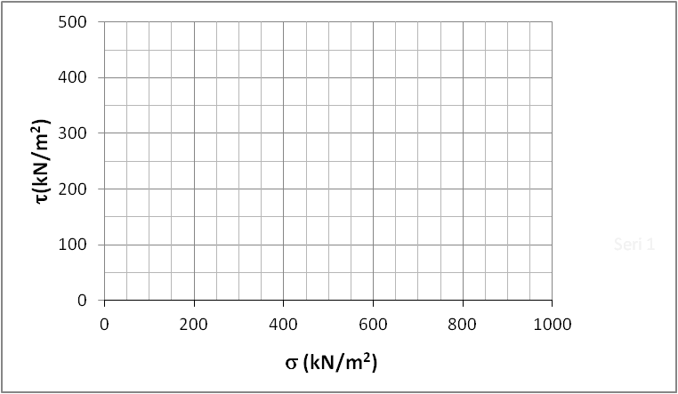

Name Surname: | Student No: | Group:
Q 3.

A flownet under a concrete dam lying on a permeable soil over impermeable layer is given above.
Calculate;
a) the total flow under concrete dam per unit width and time.
b) the uplift pressures acting on the marked locations at the bottom of dam due to water flow. Draw pressure distribution under the bottom of dam where it is placed 1m under ground level.
c) Determine whether there is a quick sand condition at the point A or not. If so, explain the precautions that can be taken to overwhelm the problem.

Name Surname: | Student No: | Group:
Q 4.

A soil profile is given in figure. A circular tank in 10 m diameter is constructed on the ground. At first, It is assumed that the tank is empty and the weight of the tank is negligible. Then, the height of the water will be 6 m in the tank. According to the results of the oedometer test conducted on undisturbed soil sample taken from clay layer are given in the table below,
σ₀ (kN/m²) | 0 | 25 | 50 | 100 | 200 | 400
e (void ratio) | 0.86 | 0.853 | 0.840 | 0.827 | 0.814 | 0.80

Calculate;
- the vertical stress increase in the middle of the clay layer under the center of the tank.
- the primary consolidation settlement under the center of the tank.
- the time to reach 90% consolidation in clay layer caused by the water stored in the tank.
( Tv (%90) = 0.848 )

Name Surname: | Student No: | Group:
Q 5.
An earth fill will be constructed using sandy silt material. For the soil in borrow area, void raio of the soil and specific gravity of soil solids were given as 0.8 and 2.70, respectively. The results of a Standart Proctor Test conducted on the soil samples are given in the table below.
γ_{n}(kN/m³) | 18,32 | 19,19 | 20,05 | 20,66 | 20,5 | 19,98
w(%) | 11 | 13 | 15 | 17 | 19 | 21

- Plot the compaction curve. Determine the maximum dry unit weight and optimum moisture content of the soil.
- Moist mass and dry mass of the soil sample taken from compacted soil are 1330 g and 1160 g respectively. Relative compaction of 95% and optimum moisture content of ±3 were stated in specification. Determine whether the compaction meets the requirements or not.
- Calculate how much filler material is necessary for compacted fill of 50000 m³ considering the properties in part b.

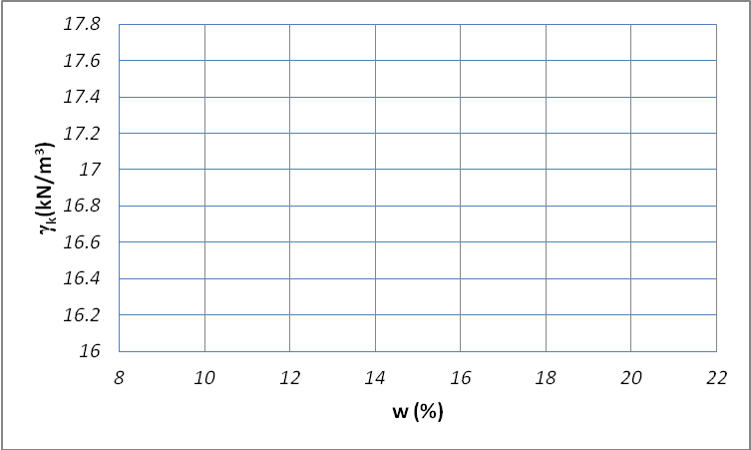

Time is 90 minutes. Good luck.

